**Network Cisco Switches & Routers:**

**“Course Project Phase 1”**

**Lab 1**

**CIS 202**

**Rafat Khandaker**

**11/11/18**

**Objective**

**Part I: Planning**

* Create the topology map of three routers and three switches (Packet Tracer or MS Visio).
* **Addressing Design:** Use private IP network 172.22.0.0/16 to create your subnets derived using your own original scheme with the following guidelines.
  + IP addresses should be labeled for each router interface on your workspace topology, both serial and Fast Ethernet interfaces. Use VLSM with CIDR notation in lieu of the subnet mask on your labels.
  + Serial links should support two hosts, one for each end.
  + The 3 Switched Ethernet networks will be as follows:
    - A server LAN of 6 host addresses
    - An employee LAN of 126 host addresses
    - A manager LAN of 30 host addresses
  + Label each of your test workstations with its IP address.

**Part II: Live Implementation**

* Following your topology plan, select a cable, and physically connect a switch to each of the router's respective Fast Ethernet interfaces.
  + Label the cables (Cat5 straight, crossover, or serial crossover).
* Make sure you have the physical serial interfaces in place, and create the physical cable linkage by redundantly connecting serial links between the routers.
  + Each router will have two serial links, one for each of the other two routers, ie, a triangle.
* Configure one test host per switch, and connect each to its respective switch.
* Change the hostnames of the Routers and Switches to reflect the names on the topology map.
* Provide each router's Fast Ethernet interfaces with IP addresses.
* Provide the host machines with an IP address such that they can ping the Fast Ethernet Interface.

**Configuration Explained**

All Ethernet cables used in this example are straight through cables because we use unlike devices to connect between host and switch and switch to router. The router to router connections are connected with serial crossover cables, which enable connection to WAN network. The IP addresses are assigned by network needs and efficiently addressed with minimum Address scheme. No network routing protocol is used with the routers, instead they are statically assigned to the router based on the configuration. I chose to do this because this improves the performance of the route since, the current diagram is limited and we do not expect to scale this diagram for new networks at the moment. All link lights are fully functional and configured on the device and a ping test was made from the PC with **172.22.0.2** IP Address.

**Diagram**

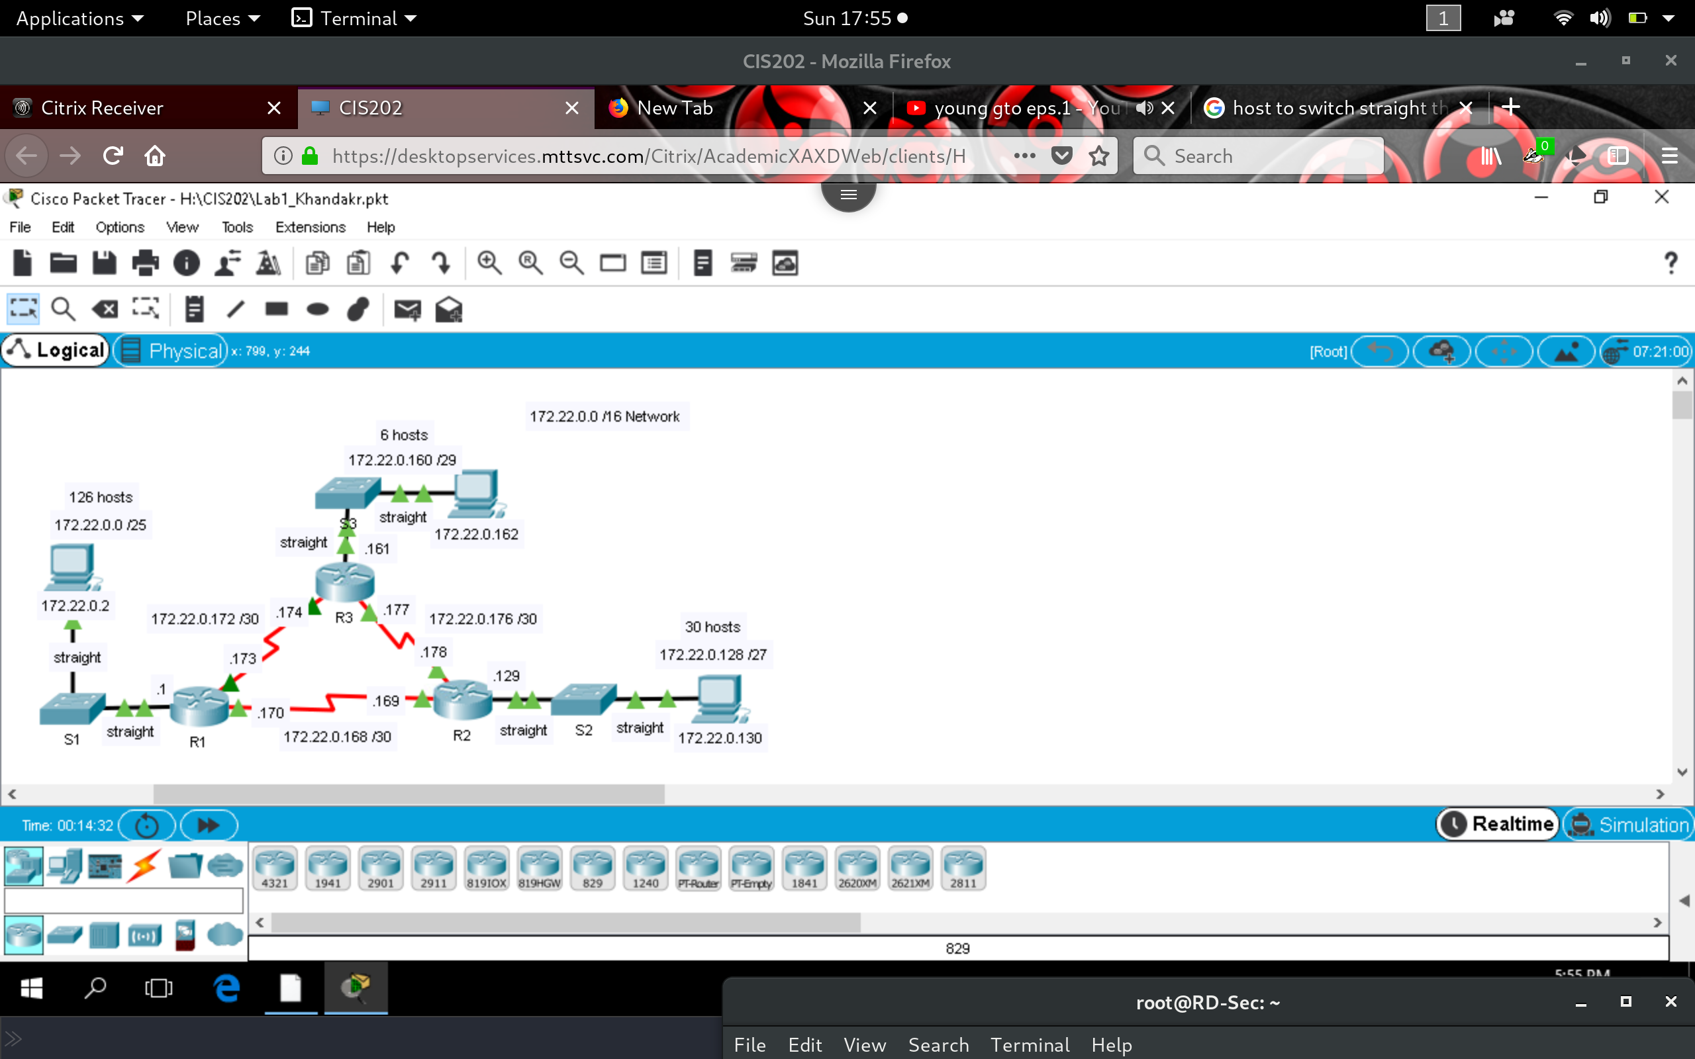

**PC configuration**

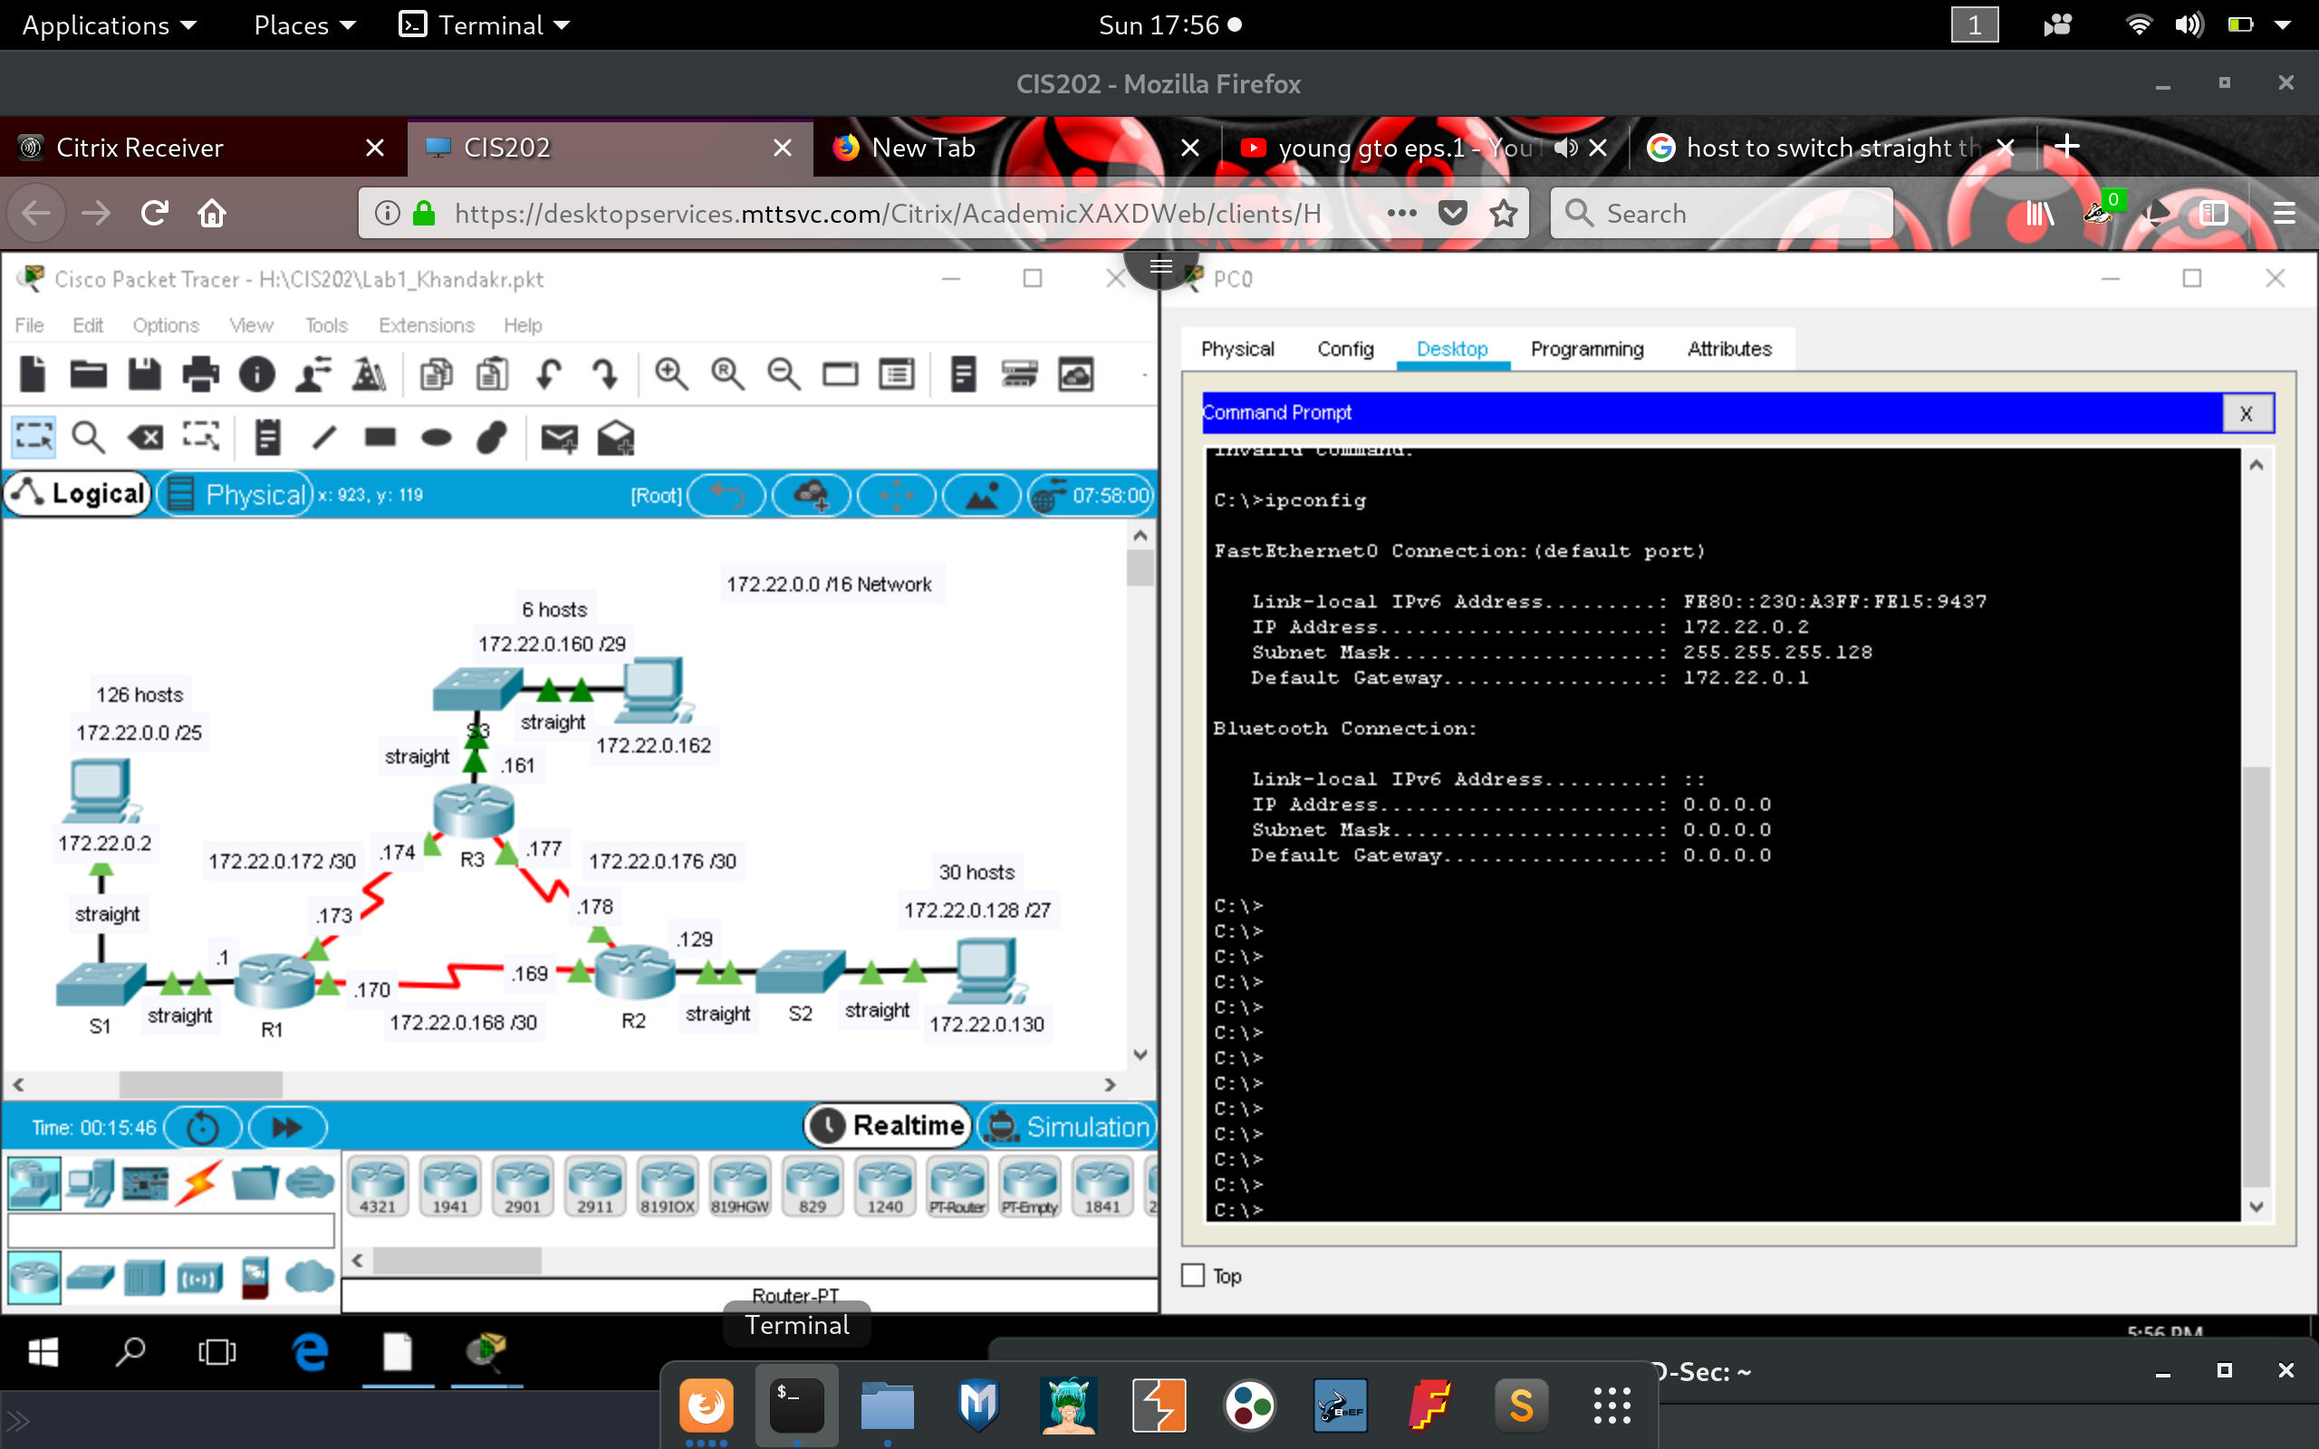

**Ping test to default gateway**

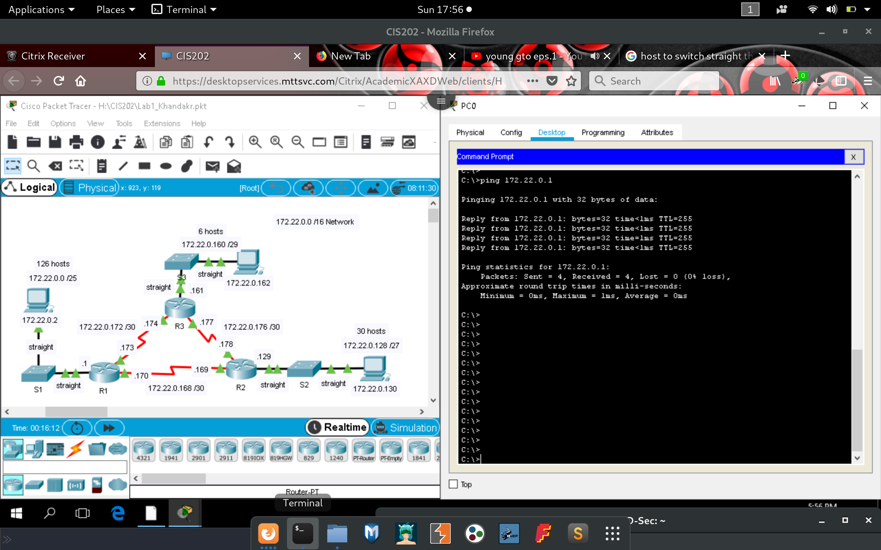

**Ping test to 172.22.0.174 /29 router interface**

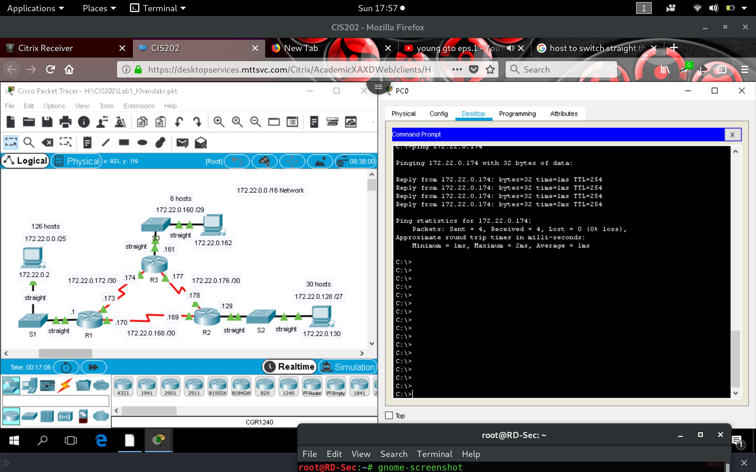

**Ping test to 172.22.0.169 router interface**

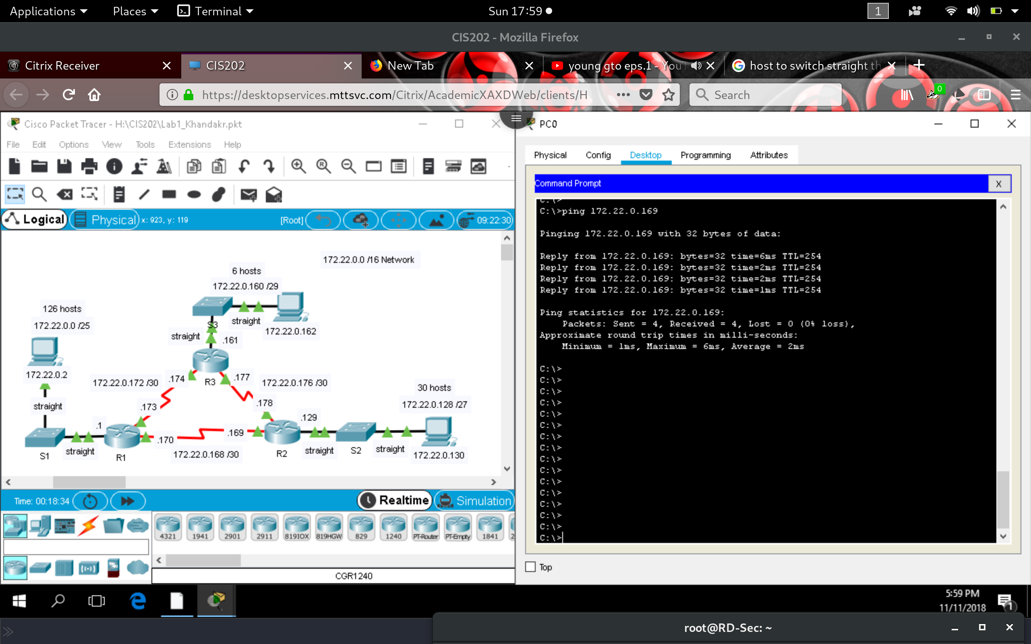

**Ping to PC: 172.22.0.162**

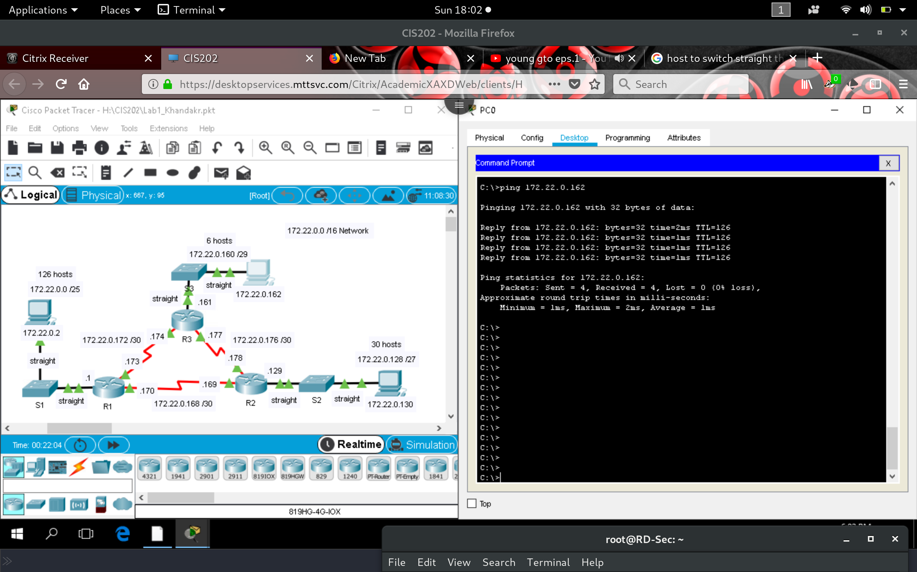

**Ping to PC: 172.22.0.130**

